Good Progress in SSVP Shop Tonga

After several weeks of delay in March/April due to flooding caused by some unusual weather conditions Phase 1 was duly completed in early May with completion of the new foundation and the two 40’ containers lifted into place a week later. The two 40’ containers were purchased locally as part of the financial assistance from SSVP NZ.

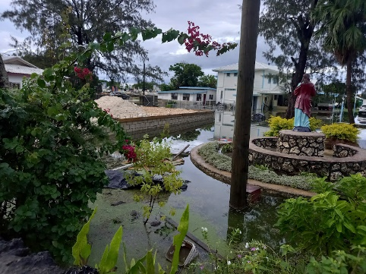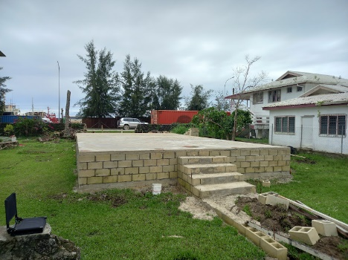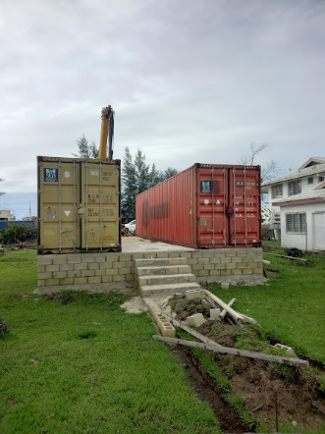

SSVP President said ‘it has not been easy waiting for a break in weather so that we can start the project, now that Phase 1 is completed our attention is now turned to Phase 2 and this has started last week and should be completed in 2 to 3 weeks time. I am thankful for the patience shown by all concern especially our conference members, parishioners and parish priest.

We continued to be grateful for the continued funding assistance and support from Arthur Schultze and Anne Marie McCarten of SSVP New Zealand. A budget for Phase 2 was agreed upon and funds transferred last week to our shop account. Timber and roofing have been ordered and delivered to the site as required for the contractor to begin the work. Phase 2 should be completed in 2-3 week maximum if current good weather continues.

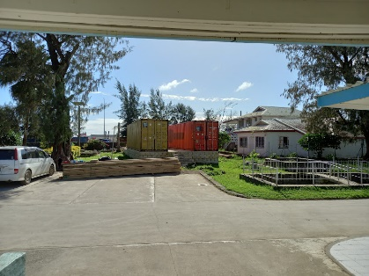We have reported the work in progress to the National Council and SSVP New Zealand with detailed expenses and report. During several key construction phases Conferences have provided refreshments and lunch for the construction workers as show of support and partnership for the project. The local Conferences also play their part by contributing some funds for the project.

Blessing of the new shop is being planned for the SVDP Feast Day on 27th September 2024.